Indian utility Patent uspto Publication - Time Duration Minimum 15 days to 90 Days
Application Start: 01-07-2026
Patent Title: Smart Fertilizer Spraying System Using Plant Disease Severity Analysis
Applicant & Inventor
S.no | Reference Name | Mobile Number | Gender | Applicant Address: Name,Designation, Department , College Name, Address with Pincode, Email-ID, Phone No. | Signature | Received  Payment with date | Registration  (Hold / Registered)
1 |  | 9493682726 |  | Patent Applicant:  Srinivasa Ramanujan Institute of Technology, Rotarypuram, Anantapur, Andhra Pradesh – 515701.
2 |  |  | Female | Inventors:  Dr. C.Sasikala  Associate Professor,  Department of CSE ,  Srinivasa Ramanujan Institute of Technology, Rotarypuram,  Anantapur, Andhra Pradesh – 515701.  Email: sasikala.cse@srit.ac.in  Phone No. 9493682726
3 |  |  | Female | Bomma Revathi  IV Year Student  Department of CSE (AI & ML),  Srinivasa Ramanujan Institute of Technology, Rotarypuram,  Anantapur, Andhra Pradesh – 515701.  Email: 224g1a3380@srit.ac.in  Phone No. 9491888278 | 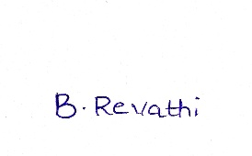
4 |  |  | Female | Ganne Sreeja  IV Year Student  Department of CSE (AI & ML),  Srinivasa Ramanujan Institute of Technology, Rotarypuram,  Anantapur, Andhra Pradesh – 515701.  Email: 224g1a33a9@srit.ac.in  Phone No. 9398344792 | 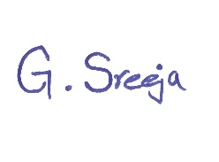
5 |  |  | Female | Yaparla Sravani  IV Year Student  Department of CSE (AI & ML),  Srinivasa Ramanujan Institute of Technology, Rotarypuram,  Anantapur, Andhra Pradesh – 515701.  Email: 224g1a33a4@srit.ac.in  Phone No. 6304098979 | 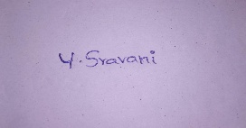
6 |  |  | Male | Yanamala Trinesh Reddy  IV Year Student  Department of CSE (AI & ML),  Srinivasa Ramanujan Institute of Technology, Rotarypuram,  Anantapur, Andhra Pradesh – 515701.  Email: 234g5a3311@srit.ac.in  Phone No. 9398607030 | 

